**Aim:** Creating a private cloud using open source.

**Theory:**

**Eucalyptus**

Eucalyptus (Elastic Utility Computing Architecture for Linking Your Programs To Useful Systems) was released in May 2008,creator of the leading Open-Source Private Cloud platform. They were incorporated as an organization in January 2009Headquartered in Santa Barbara, California. Eucalyptus software is available under GPL (General Public License) that helps in creating and managing a private or even a publicly accessible cloud. It provides an EC2 (Elastic Compute Cloud)-compatible cloud computing platform and S3 (Simple Storage Service)-compatible cloud storage platform.

Eucalyptus is one of the key for open source cloud platforms which makes it much popular. The client tools used for Eucalyptus is same as that of AWS, because Eucalyptus services are available through EC2/S3 compatible APIs.



Figure 1: Architecture of Ubuntu Enterprise Cloud

**Building a private cloud**

Private Cloud is also called an internal cloud which is mainly designed to control the data of an organization, than by getting the resources from other hosted services. This section describes about the basic installation and configuration of Ubuntu Enterprise Cloud as well as the steps for creating a virtual machine image and uploading the image to the private cloud.

**Installation and Configuration**

The UEC setup is shown in figure 2 below. Includes two servers (Server 1 and Server 2) which will run a Lucid 64-bit server version and the third system which will run a Lucid Desktop 64-bit version (Client 1)



Figure 2: UEC basic setup with Three Machines

Steps in Configuring an Open Source Private Cloud

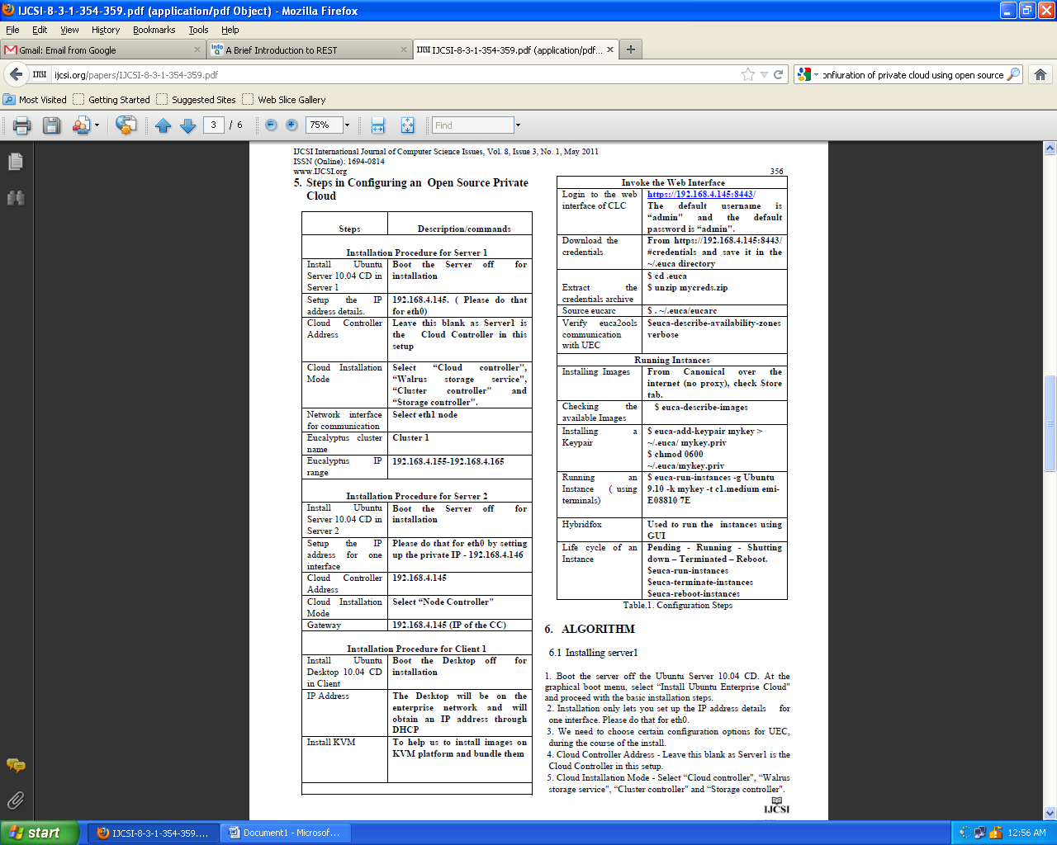

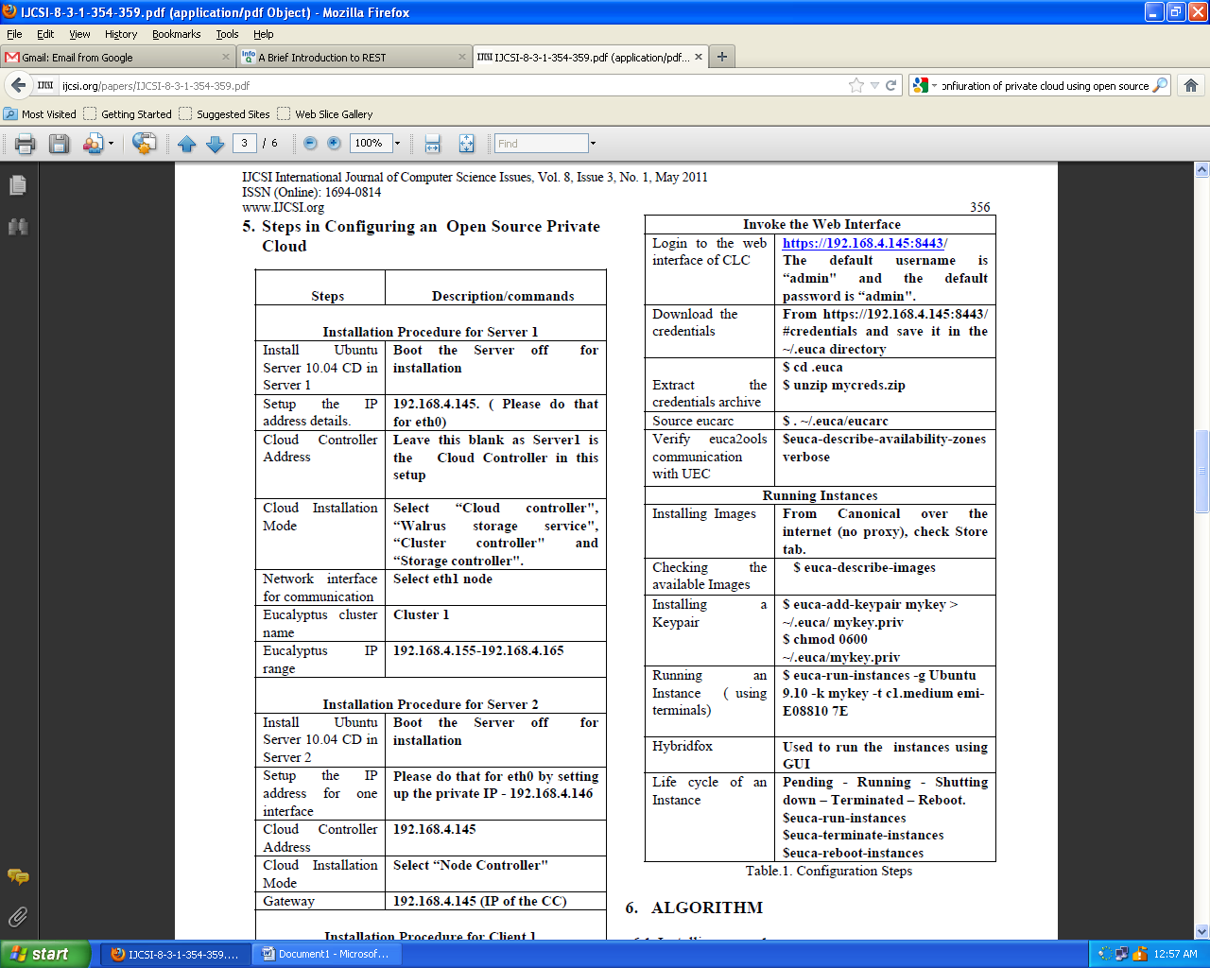

**ALGORITHM**

**Installing server1**

1. Boot the server off the Ubuntu Server 10.04 CD. At the graphical boot menu, select “Install Ubuntu Enterprise Cloud" and proceed with the basic installation steps.

2. Installation only lets you set up the IP address details for one interface. Please do that for eth0.

3. We need to choose certain configuration options for UEC, during the course of the install.

4. Cloud Controller Address - Leave this blank as Server1 is the Cloud Controller in this setup.

5. Cloud Installation Mode - Select “Cloud controller", “Walrus storage service", “Cluster controller" and “Storage controller".

6. Network interface for communication with nodes - eth1

7. Eucalyptus cluster name – cluster1

8. Eucalyptus IP range - 192.168.4.155-192.168.4.165.

**Installing server 2**

1. Boot the server off the Ubuntu Server 10.04 CD. At the graphical boot menu, select “Install Ubuntu Enterprise Cloud" and proceed with the basic installation steps.

2. Installation only lets us to set up the IP address for one interface. Please do that for eth0 by setting up the private IP - 192.168.4.146.

3. Then choose certain configuration options for UEC, during the course of the install. Ignore all the settings, except the following:

4. Cloud Controller Address - 192.168.4.145

5. Cloud Installation Mode - Select “Node Controller"

6. Gateway - 192.168.4.145 (IP of the CC) .

**Installing Client 1**

The purpose of Client1 machine is to interact with the cloud setup, for bundling and registering new Eucalyptus Machine Images (EMI).

1. Boot the Desktop off the Ubuntu Desktop 10.04 CD and install. The Desktop will be on the enterprise network and will obtain an IP address through DHCP.

2. Install KVM to help us to install images on KVM platform and bundle them:

$apt_get install qemu_kvm .

**Algorithm for Invoking the Web Interface**

1. Login to the web interface of CLC by using the following link https://192.168.4.145:8443. The default username is “admin" and the default password is “admin".

2. Note that the installation of UEC installs a self signed certificate for the web server. The browser will warn us about the certificate not having been signed by a trusted certifying authority. Authorize the browser to access the server with the self signed certificate.

3. When you login for the first time, the web interface prompts to change the password and provide the email ID of the admin. After completing this mandatory step, download the credentials archive from https://192.168.4.145:8443/ #credentials and save it in the ~/.euca directory.

4. Extract the credentials archive:

$ cd .euca

$ unzip mycreds.zip

5. Source eucarc script to make sure that the environmental variables used by euca2ools are set properly.

$ . ~/.euca/eucarc

6. To verify that euca2ools are able to communicate with the UEC, try fetching the local cluster availability details shown in Fig.



7. If the free/max VCPUs are set as 0 in the above list, it means that the node did not get registered automatically. Use the following on Server1 and approve when prompted to add 192.168.4.146 as the Node Controller: $sudo euca_conf --discover-nodes

**Conclusion**: Hence we have successfully created private cloud using open source.